# **Laboratory-4**

## **Question**

## Implement Intermediate code generation of assignment statements and expressions using Lex / Yacc.

### **Lex File (lex.l):**

%{

#include"y.tab.h"

**extern** **char** yyval;

%}

%%

[0-9]+ {yylval.symbol=(**char**)(yytext[0]);**return** NUMBER;}

[a-z] {yylval.symbol= (**char**)(yytext[0]);**return** LETTER;}

. {**return** yytext[0];}

\n {**return** 0;}

%%

### **Yacc File (par.y):**

%{

#include"y.tab.h"

#include<stdio.h>

**char** addtotable(**char**,**char**,**char**);

**int** index1=0;

**char** temp = 'A'-1;

**struct** expr{

**char** operand1;

**char** operand2;

**char** **operator**;

**char** result;

};

%}

%**union**{

**char** symbol;

}

%left '+' '-'

%left '/' '*'

%token <symbol> LETTER NUMBER

%type <symbol> exp

%%

statement: LETTER '=' exp ';' {addtotable((**char**)$1,(**char**)$3,'=');};

exp: exp '+' exp {$$ = addtotable((**char**)$1,(**char**)$3,'+');}

|exp '-' exp {$$ = addtotable((**char**)$1,(**char**)$3,'-');}

|exp '/' exp {$$ = addtotable((**char**)$1,(**char**)$3,'/');}

|exp '*' exp {$$ = addtotable((**char**)$1,(**char**)$3,'*');}

|'(' exp ')' {$$= (**char**)$2;}

|NUMBER {$$ = (**char**)$1;}

|LETTER {(**char**)$1;};

%%

**struct** expr arr[20];

**void** yyerror(**char** *s){

printf("Errror %s",s);

}

**char** addtotable(**char** a, **char** b, **char** o){

temp++;

arr[index1].operand1 =a;

arr[index1].operand2 = b;

arr[index1].**operator** = o;

arr[index1].result=temp;

index1++;

**return** temp;

}

**void** threeAdd(){

**int** i=0;

**char** temp='A';

**while**(i<index1){

**if** (arr[i].**operator** != '=')

printf("%c = ",arr[i].result);

printf("%c ",arr[i].operand1);

printf("%c ",arr[i].**operator**);

printf("%c ",arr[i].operand2);

i++;

temp++;

printf("\n");

}

}

**int** yywrap(){

**return** 1;

}

**int** main(){

printf("Enter the expression: ");

yyparse();

threeAdd();

**return** 0;

}

### **Output:**

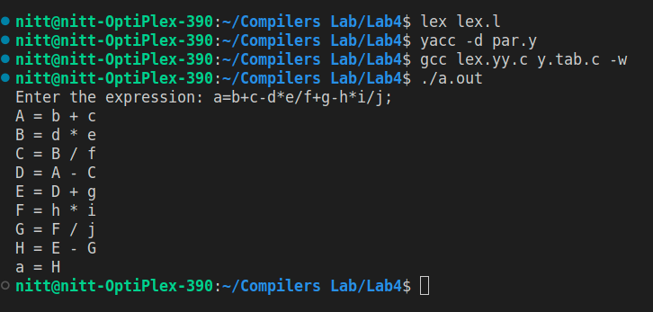

## **Result:**

Code for syntax analysis of conditional constructs was implemented successfully.